1. The Core Difference
- Web Worker (Dedicated): Is linked to the single script (tab/window) that created it. If you open three tabs of the same website, you will create three separate worker threads. They do not know about each other.
- Shared Worker: Is accessible by multiple scripts (tabs, windows, iframes) running on the same domain (origin).If you open three tabs of the same website, they all connect to the same Shared Worker instance.

2. Comparison Table
Feature | Dedicated Web Worker | Shared Worker
Scope | One tab/window only. | Multiple tabs/windows (same origin).
Lifespan | Dies when the parent tab is closed. | Dies only when all connected tabs are closed.
Communication | Direct postMessage() and onmessage. | Communicates via ports. Requires onconnect event.
Complexity | Simple. Easier to set up. | Higher. Requires managing port connections.
Browser Support | Excellent (All modern browsers). | Good, but historically spotty on mobile (e.g., Android Chrome).
Best For | Heavy calculations for a specific page. | Syncing data across tabs or sharing a WebSocket.

3. Use Cases
When to use a Dedicated Worker
Use this when you simply need to move heavy processing off the main thread to keep your UI responsive.
- Image Processing: Applying filters to an image uploaded by the user.
- Data Parsing: Parsing a massive JSON file or CSV export.
- Ray Tracing: Rendering 3D graphics logic.
When to use a Shared Worker
Use this when you need "Single Source of Truth" across multiple open tabs.
- Shared WebSocket: Instead of opening 5 WebSocket connections for 5 tabs (which wastes server resources), you open one in the Shared Worker and broadcast messages to all tabs.
- Cross-Tab State: If a user logs out in Tab A, the Shared Worker can tell Tab B and C to redirect to the login page immediately.
- Locking Systems: Ensuring a file is only being edited in one tab at a time.

4. Code Comparison
Dedicated Worker (Simple) 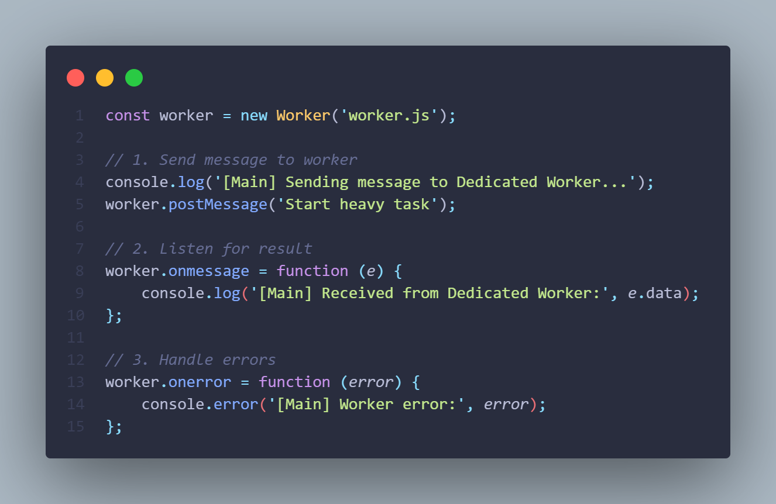

Shared Worker (Complex)
